**Capstone Project**

* ***Objective:***

The objective is to develop a comprehensive QA and test suite for the Sporty Shoes website. The QA effort will require the following:

1. Browser-based end-user testing using Selenium WebDriver with TestNG Framework.
2. Load Testing using JMeter.
3. API Testing with Cucumber.
4. API Testing with Postman and Rest Assured.

* ***Tools Required*:**
* Postman
* Java 11
* Maven
* Rest Assured Maven dependency version 4.5.1
* TestNG Maven dependency version 7.1.0
* JMeter
* Cucumber Dependencies
* Selenium,WebDriver dependency
* Eclipse IDE
* GitHub Account
* ***GitHub Link:***<https://github.com/Shivam6190/Java-fsd>
* ***Steps to complete the Capstone project:***

**Step 1**: Opening the Website

Step 1.1: Launch the Application under test

* Go to github URL <https://github.com/Simplilearn-Edu/SportyShoes.git>
* Click on Green button which has Code written on it. Click on Download Zip
* The download zip file will be in your download folder
* Extract all the files in downloads folder

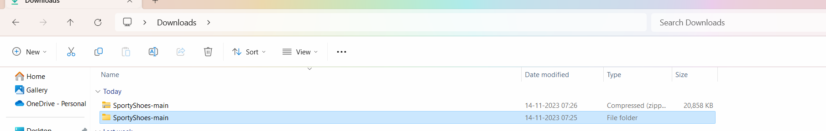

Step 1.2: Go inside the folder SportyShoes-main and then again go in the folder SportyShoes-main

Step 1.3: Go inside the folder where you see the sporty-shoes-v1 jar file

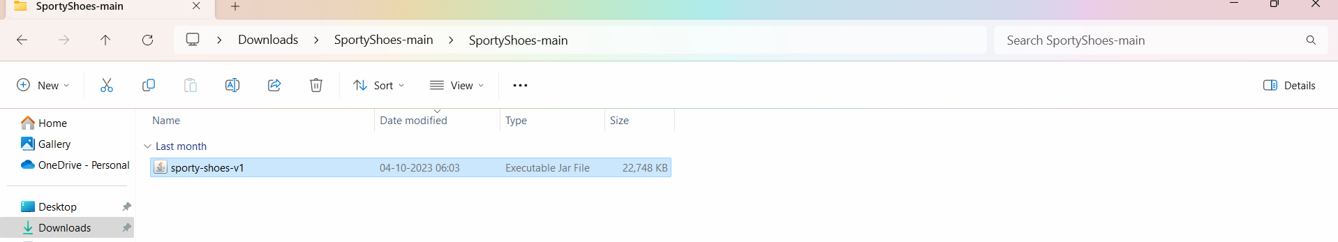

Step 1.4: Start cmd prompt in the same folder

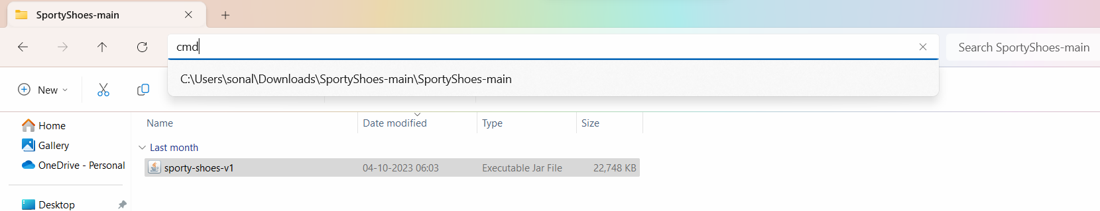

Step 1.5: Execute the java command to run the jar file and deploy the application

java -jar sporty-shoes-v1.jar

OR

java -jar -Dserver.port=8100 sporty-shoes-v1.jar

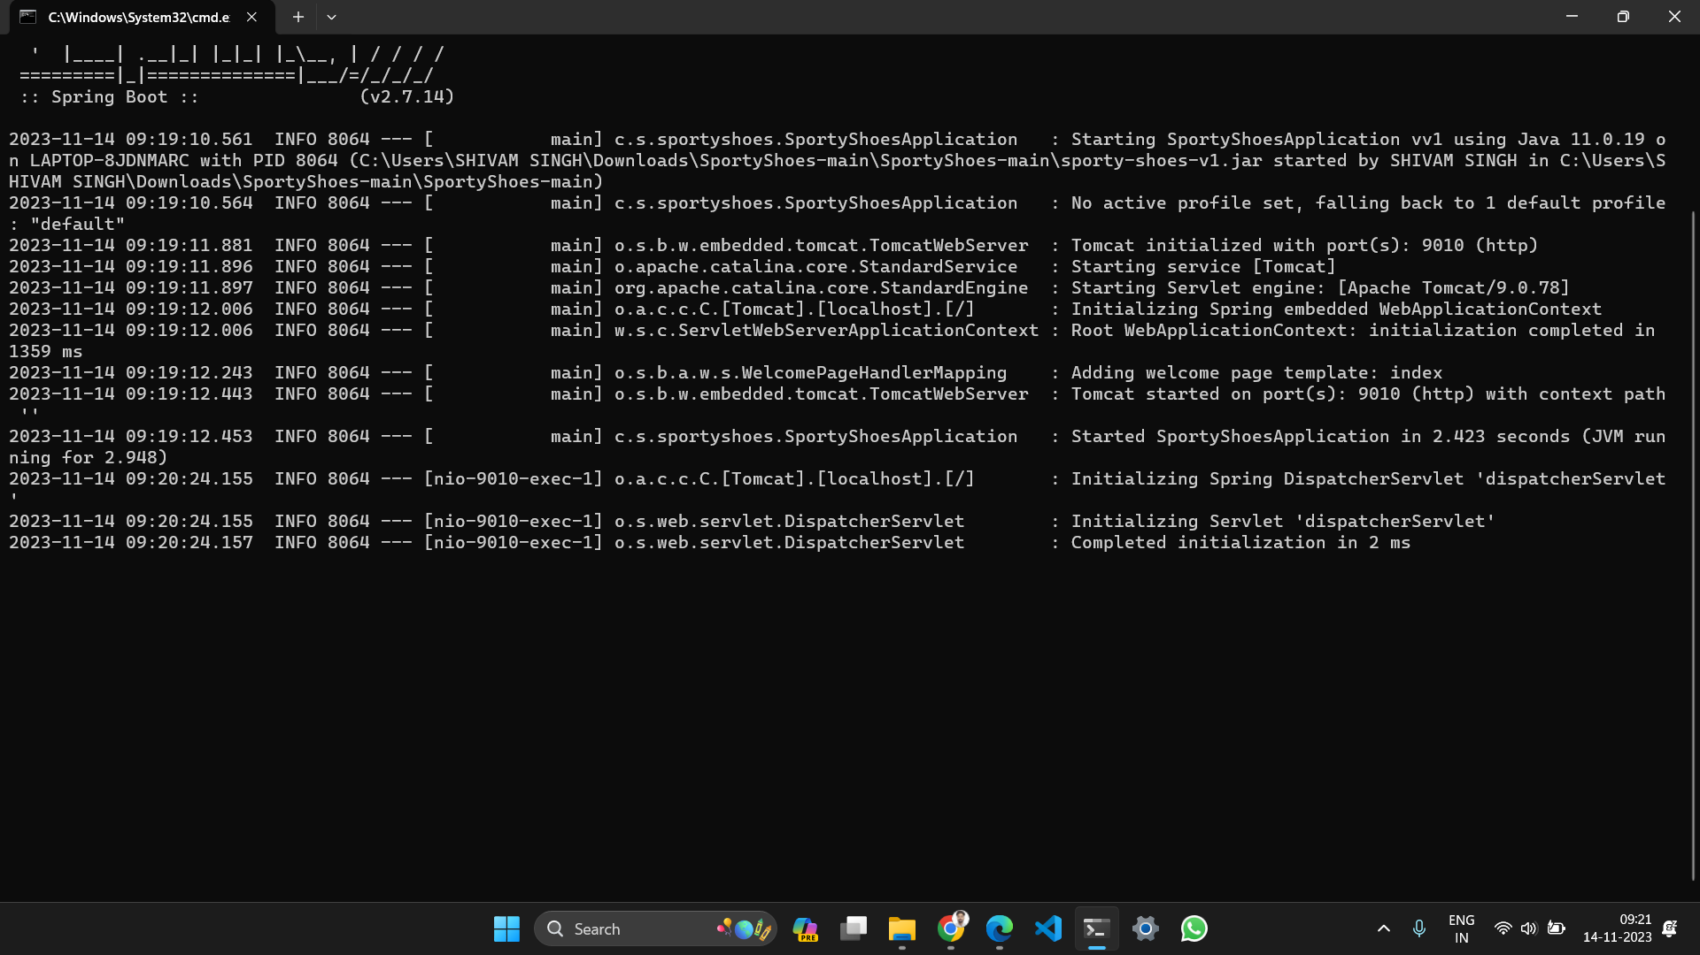

**Step 2**: Implementing Postman Steps:

Step 2.1: Get all product using GET Request

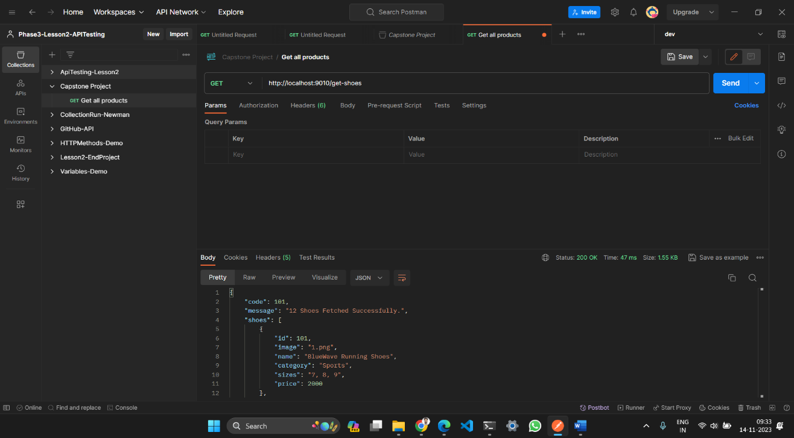

Step 2.1: Get all users using GET Request

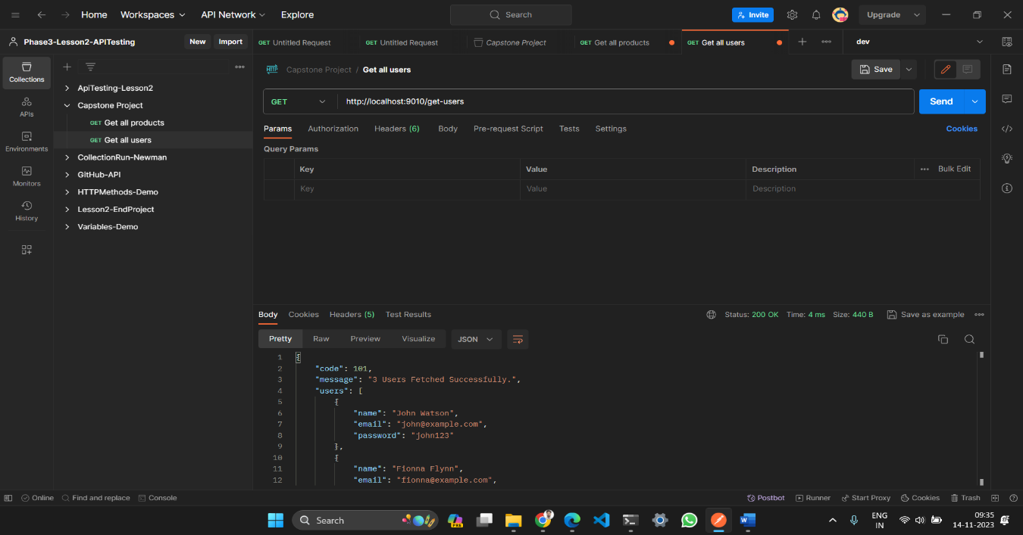

Step 2.3: Add a product using POST METHOD

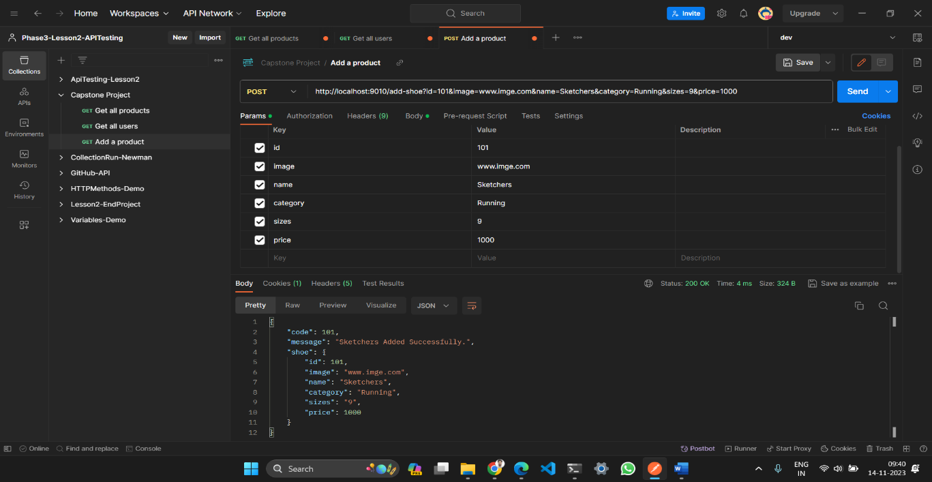

Step 2.4: Update a product using PUT METHOD

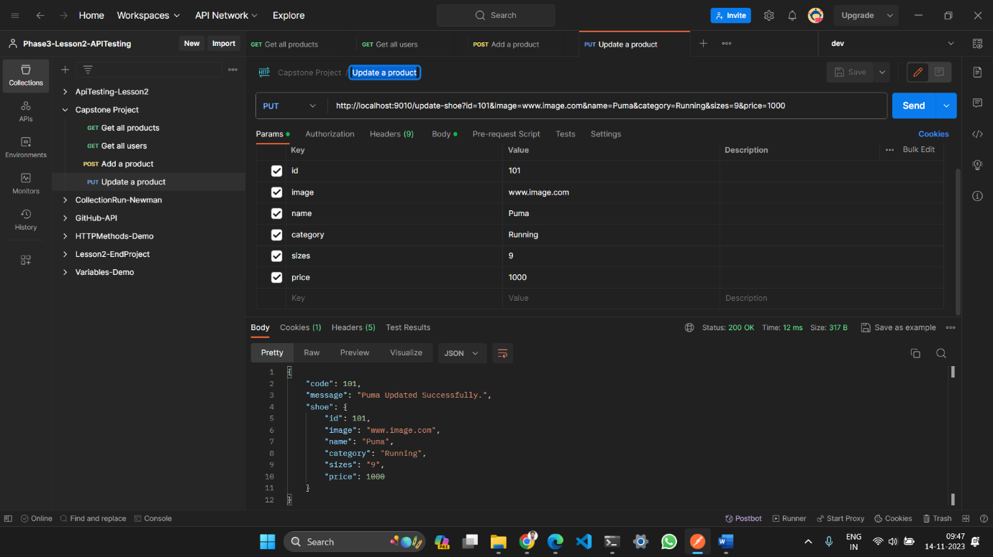

Step 2.5: Deleta a product using DELETE Request

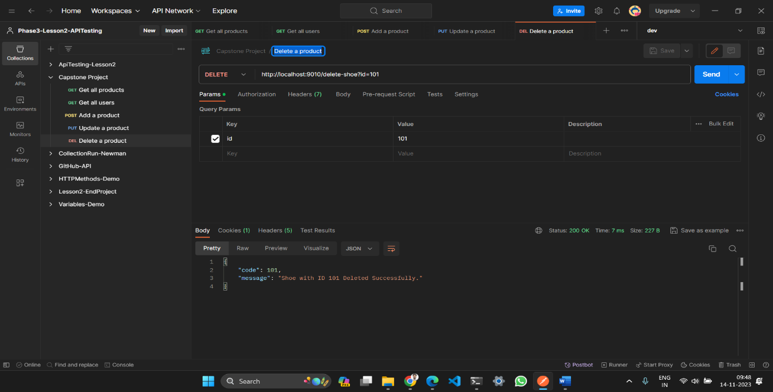

**Step 3:** Implementing Rest Assured Methods:

Step 3.1: Create a maven project by the name Capstone_Project

Step 3.2: Add the required dependencies in the pom file.

Step 3.2: Create a package by the name com.sporty.shoe.restAssuredScripts

Step 3.3; Create a package where the code for GET Method is scripted

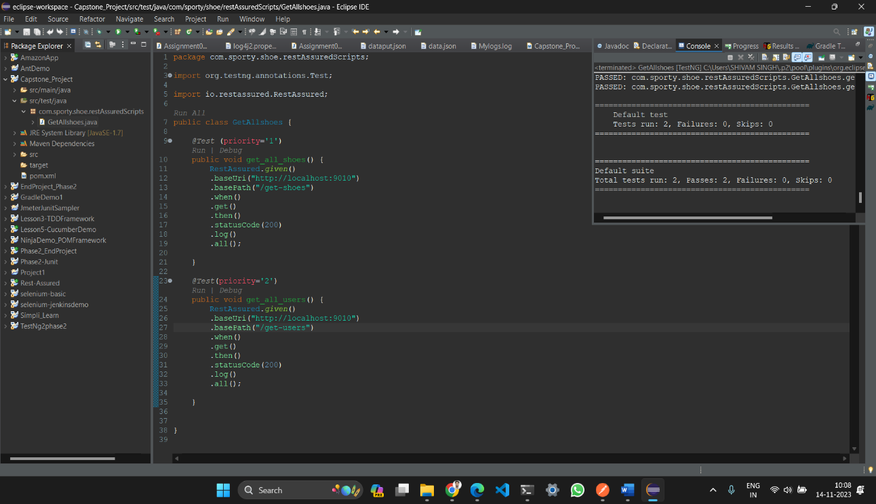

Step 3.4: Create a class for POST and PUT Method Request

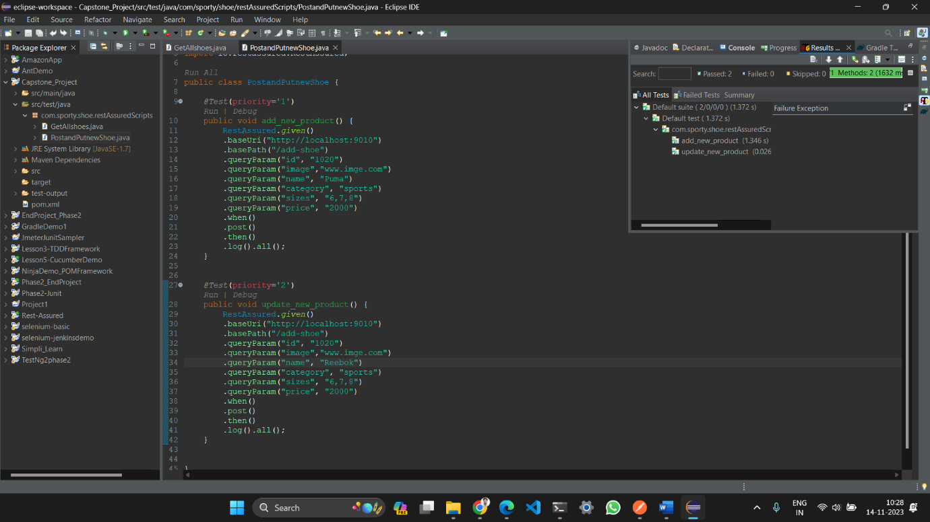

Step 3.5: Create a class for DELETE Request

